CS 600 Homework 11 | CWID 10430147 | Divyendra Patil | Username: dpatil3  
Date: 11/21/2017

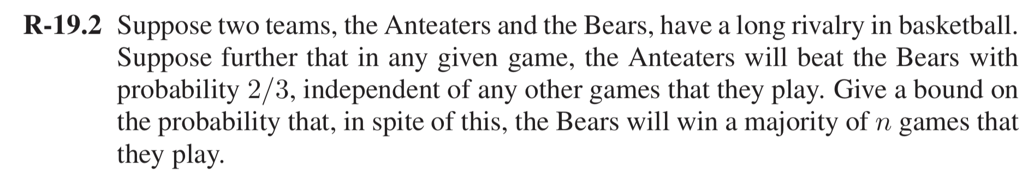

We are Given that the Independent probability that Anteater will win = 2/3

Therefore, the Independent Probability that Bear will win = 1/3

We now need to find the probability bound where Bears wins majority of games.   
And for Bears to win majority of the games, they need to win 50% of the matches.

Using the Chernoff’s bound:

$$P\left(X>\left(1+δ\right)μ\right) < {\left[\frac{e^{δ}}{{(1+δ)}^{(1+δ)}}\right]}^{μ}$$

Let $X_{i}$ be the random independent trials for Games being chosen.

Hence, $X= \sum_{i=1}^{n}{1}=n$

i.e. $X = n$

$μ$ is the mean probability of each independent probability of event

$$μ=E\left(x\right)= \sum_{i=1}^{n}{P_{i}}$$

$$= \sum_{i=1}^{n}{\frac{1}{3}}$$

$$=\frac{1}{3}n$$

$$P\left(X>\left(1+δ\right)μ\right) < {\left[\frac{e^{δ}}{{(1+δ)}^{(1+δ)}}\right]}^{μ}$$

To find the upper bound that no. of games bears Win=0.5n is

$$\left(1+δ\right)μ=\frac{n}{2}$$

$$\left(1+δ\right)(\frac{1}{3}n) =\frac{n}{2}$$

$$\left(1+δ\right)=\frac{3}{2}$$

$$δ=\frac{1}{2}$$

$$\sum{P\left(X>\frac{n}{2}\right) < {\left[\frac{e^{\frac{1}{2}}}{{(\frac{3}{2})}^{(\frac{3}{2})}}\right]}^{n}}$$

$< {\left[\frac{1.65}{1.837}\right]}^{n}$

$< {\left[0.898\right]}^{n}$

Thus, the upper bound on probability for $δ=\frac{1}{2}$ using Chernoff Bound is < 0.9n

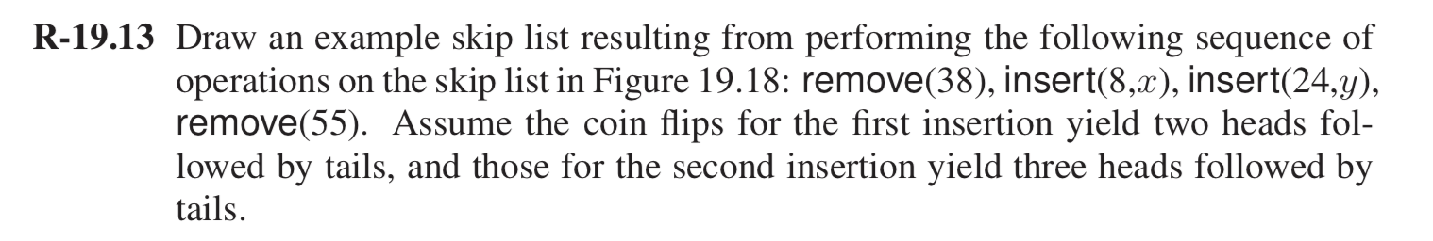

Following is the path highlighted for removing 38

|  |  |  |  |  |  |  |  |  |  |  |  |  |
| --- | --- | --- | --- | --- | --- | --- | --- | --- | --- | --- | --- | --- |
| **S­5** | **- ∞** |  |  |  |  |  |  |  |  |  |  | **+ ∞** |
| **S4** | **- ∞** |  | **17** |  |  |  |  | **42** |  |  | **55** | **+ ∞** |
| **S3** | **- ∞** |  | **17** |  |  |  |  | **42** |  |  | **55** | **+ ∞** |
| **S2** | **- ∞** |  | **17** |  | **31** |  |  | **42** |  |  | **55** | **+ ∞** |
| **S1** | **- ∞** | **12** | **17** |  | **31** | **38** |  | **42** | **44** |  | **55** | **+ ∞** |
| **S0** | **- ∞** | **12** | **17** | **20** | **31** | **38** | **39** | **42** | **44** | **50** | **55** | **+ ∞** |

Insert 8

|  |  |  |  |  |  |  |  |  |  |  |  |  |
| --- | --- | --- | --- | --- | --- | --- | --- | --- | --- | --- | --- | --- |
| **S5** | **- ∞** |  |  |  |  |  |  |  |  |  |  | **+ ∞** |
| **S4** | **- ∞** |  |  | **17** |  |  |  | **42** |  |  | **55** | **+ ∞** |
| **S3** | **- ∞** |  |  | **17** |  |  |  | **42** |  |  | **55** | **+ ∞** |
| **S2** | **- ∞** | **8** |  | **17** |  | **31** |  | **42** |  |  | **55** | **+ ∞** |
| **S1** | **- ∞** | **8** | **12** | **17** |  | **31** |  | **42** | **44** |  | **55** | **+ ∞** |
| **S0** | **- ∞** | **8** | **12** | **17** | **20** | **31** | **39** | **42** | **44** | **50** | **55** | **+ ∞** |

Insert 24

|  |  |  |  |  |  |  |  |  |  |  |  |  |  |
| --- | --- | --- | --- | --- | --- | --- | --- | --- | --- | --- | --- | --- | --- |
| **S5** | **- ∞** |  |  |  |  |  |  |  |  |  |  |  | **+ ∞** |
| **S4** | **- ∞** |  |  | **17** |  | **24** |  |  | **42** |  |  | **55** | **+ ∞** |
| **S3** | **- ∞** |  |  | **17** |  | **24** |  |  | **42** |  |  | **55** | **+ ∞** |
| **S2** | **- ∞** | **8** |  | **17** |  | **24** | **31** |  | **42** |  |  | **55** | **+ ∞** |
| **S1** | **- ∞** | **8** | **12** | **17** |  | **24** | **31** |  | **42** | **44** |  | **55** | **+ ∞** |
| **S0** | **- ∞** | **8** | **12** | **17** | **20** | **24** | **31** | **39** | **42** | **44** | **50** | **55** | **+ ∞** |

Following is the path highlighted to delete 55

|  |  |  |  |  |  |  |  |  |  |  |  |  |  |
| --- | --- | --- | --- | --- | --- | --- | --- | --- | --- | --- | --- | --- | --- |
| **S5** | **- ∞** |  |  |  |  |  |  |  |  |  |  |  | **+ ∞** |
| **S4** | **- ∞** |  |  | **17** |  | **24** |  |  | **42** |  |  | **55** | **+ ∞** |
| **S3** | **- ∞** |  |  | **17** |  | **24** |  |  | **42** |  |  | **55** | **+ ∞** |
| **S2** | **- ∞** | **8** |  | **17** |  | **24** | **31** |  | **42** |  |  | **55** | **+ ∞** |
| **S1** | **- ∞** | **8** | **12** | **17** |  | **24** | **31** |  | **42** | **44** |  | **55** | **+ ∞** |
| **S0** | **- ∞** | **8** | **12** | **17** | **20** | **24** | **31** | **39** | **42** | **44** | **50** | **55** | **+ ∞** |

|  |  |  |  |  |  |  |  |  |  |  |  |  |
| --- | --- | --- | --- | --- | --- | --- | --- | --- | --- | --- | --- | --- |
| **S5** | **- ∞** |  |  |  |  |  |  |  |  |  |  | **+ ∞** |
| **S4** | **- ∞** |  |  | **17** |  | **24** |  |  | **42** |  |  | **+ ∞** |
| **S3** | **- ∞** |  |  | **17** |  | **24** |  |  | **42** |  |  | **+ ∞** |
| **S2** | **- ∞** | **8** |  | **17** |  | **24** | **31** |  | **42** |  |  | **+ ∞** |
| **S1** | **- ∞** | **8** | **12** | **17** |  | **24** | **31** |  | **42** | **44** |  | **+ ∞** |
| **S0** | **- ∞** | **8** | **12** | **17** | **20** | **24** | **31** | **39** | **42** | **44** | **50** | **+ ∞** |

The 1st insertion produced 2 heads, result in inserting 8 to S 1 and S 2. The 2nd insertion produced 3 heads, results in inserting 24 at 3 more additional levels.

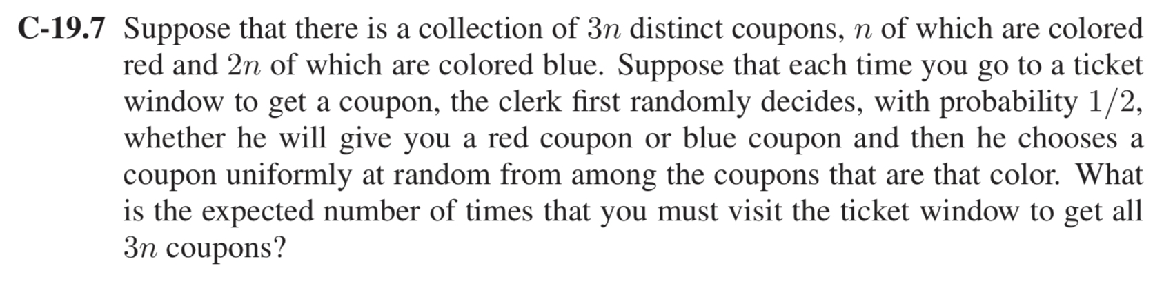

We solve the problem with the two-coupon collector method.

We have collection of 3n distinct coupons, n of which are colored red and 2n of which are colored blue.

Assuming X to be a random variable representing the number of times that we need to visit

the ticket window before we get all n coupons. We can write

X as X = X1 + X2 + ・ ・ ・ + Xn,

where Xi is the number of trips we should make to the ticket window in order to go from having i − 1 distinct coupons to having i distinct coupons.

By linearity of expectation,

E[X] = E[X1] + E[X2] + … + E[Xn]

= + + … +

= + + …. +

= n

= n Hn

where Hn is the nth harmonic number, which, as we have observed elsewhere, can

be approximated as ln n ≤ Hn ≤ ln n+1. In other words, the expected number of

times that we need to visit the ticket window in order to get at least one instance of

each of n coupons is nHn.

Assume that, the colored tickets are distributed from two separate windows.

Because we have n red colored tickets and 2nd blue colored tickets, we would need nHn trips to the red window and 2nH2n trips to the blue window to get all 3n coupons.

The Probability of choosing either red OR blue = $\frac{1}{2}$

Hence, from the equations, expected number of trips to get all the blue coupons = 4nH2n.

And because the probability of getting a red coupon is 1/2, the expected number of red tickets will be 2nH2n.

Because nHn < 2nH2n, you will get enough red tickets to get all n in these trips as well. Hence, the expected number to get all 3n tickets is **4nH2n**.